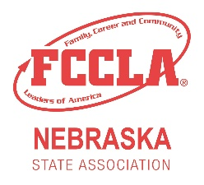
CommYOUnity Service Award

Description
This award is given to the Nebraska FCCLA member who puts the most community service hours into making their school and community a better place. These hours must be completed between August 1 and March 1.

The completed application must include: all description forms and the total number of service hours page.

Note: Community Service is unpaid, and must benefit the community. If you need more slots, please copy the 3rd page and fill out accordingly.

Example:
Date of Service: August 20, 2021
Number of Hours: 2
Organization: American Legion
Short description of Service: I picked up trash for the American Legion along the community highway. Afterwards, the Legion officers invited us back for a meal and didn’t give us any monetary reward/donation.
Verified Signature of a Supervisor: (Signature of the supervising officer)

Due March 1st to:
Nebraska FCCLA State Adviser
awards@nebraskafccla.org
CommYOUnity Service Award Application
Chapter Name
Student Name
Student Email
Adviser Name
Adviser Email

I agree that the student has completed the following community service hours to benefit the local community between August 1st and March 1st.

____________________ ______________________
Student Signature Adviser Signature

Date of Service: |  | Number of Hours:
Organization:
Short description of Service:
Signature of a Supervisor:

Date of Service: |  | Number of Hours:
Organization:
Short description of Service:
Signature of a Supervisor:
Date of Service: |  | Number of Hours:
Organization:
Short description of Service:
Signature of a Supervisor:

Date of Service: |  | Number of Hours:
Organization:
Short description of Service:
Signature of a Supervisor:

Date of Service: |  | Number of Hours:
Organization:
Short description of Service:
Signature of a Supervisor:
Total Number of Community Service Hours
Date | Hours Served
TOTAL HOURS SERVED:

