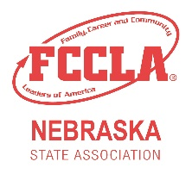
Red and White
Chapter Affiliation Awards

The Red and White Chapter Affiliation Awards are designed to encourage FCCLA members and advisers to recruit FCCLA members from their Family & Consumer Sciences courses. These students often have background knowledge of FCS and have the opportunity to learn about and interact with FCCLA within the classroom on a regular basis.
Chapter Name
School Name
School Address
City, State, Zip
School Phone
Adviser Name
Adviser Email
The level of award will be determined by the following formula:
# of Nationally Affiliated FCCLA Members | x 100
# of Students Enrolled in FCS Courses

The following levels will be recognized:
White Chapter: 75% - 100% Red Chapter: 101%-125%

Red & White Chapter: +126% Red Rose Chapter: greatest percentage reported

Award Eligibility Information
2021-22 National FCCLA Affiliation Number
2021-22 Enrollment in Family & Consumer Sciences Classes*
*If a student is in enrolled in more than one class or in one class one semester and another the second semester, only count the student once. If there is more than one Family & Consumer Sciences teacher in the school, only count the enrollment of the number of students in the FCCLA Adviser’s class.

Due March 1st to:
Nebraska FCCLA State Adviser
301 Centennial Mall S
PO Box 94987
Lincoln, NE 68509
Or email to: awards@nebraskfccla.org

Nebraska FCCLA State Office Use Only
% Membership Increase | % Affiliated | Affiliation Award Given

