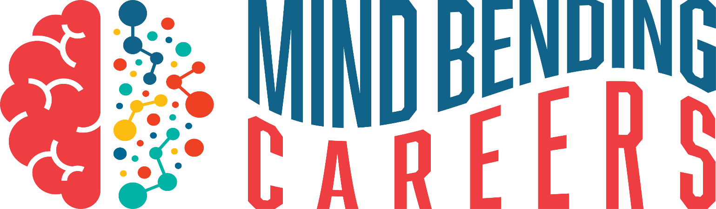
A Mental Health & Behavioral Health Experience
Tuesday, November 9, 2021
University of Nebraska-Kearney | Nebraskan Student Union

Schedule at a Glance
This is Health Care - Subject to Change!

Time | Session
9:00-9:30am | Registration
9:30-10:00am | Opening Session
10:00-10:45am | Graduate Student Panel
11:00-11:35  11:45-12:20  12:30-1:05  1:15-1:50 | Breakout Session Rotations (topics subject to change; lunch is one rotation)  - Addiction  - Advocacy  - College Scholarship Programs  - Hearing Voices – Schizophrenia Simulation  - Mental Health Community Resources  - Mind Bending Careers in Rural Nebraska
2:00-2:15 | Closing Session
2:30-3:00 | UNMC Tour (tentatively scheduled; subject to COVID protocols)

In-Person Registration: $10/participant (includes lunch)
Virtual Registration: $50/school (HOSA/FCCLA Chapters OR Health Sciences/FCS programs)
Registration Opens Wednesday, October 13 and Closes Wednesday, November 3

