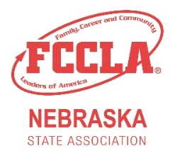
Fuel YOUR Passion Award

Description
This award was created to showcase the development of Nebraska FCCLA chapters. Chapters are asked to reflect on their involvement in Membership, Community Service, National Program efforts, Involvement on the State Level, and Involvement on the National Level.

Directions
Please fill out the application below comparing what you chapter has done this school year compared to the previous one. Fill out each section with a brief description of what your chapter did in the given year as well as attach pictures that correlate with your chapter's activity. The chapter with the most overall improvement in all categories will be awarded the Fuel YOUR Passion Award.

Chapter Name: __________________________ Adviser: _____________________
Type of Chapter: ____ Middle/Jr. ____ High School ____ Combined

To the best of our knowledge, this application is filled out accurately and completely.

Chapter Adviser Signature: ______________________________________

Chapter President Signature: _____________________________________

Due March 1st to:
Nebraska FCCLA State Adviser
301 Centennial Mall S
PO Box 94987
Lincoln, NE 68509
Or email to: awards@nebraskafccla.org
Membership
2020-2021 Efforts
2021-2022 Efforts
Evidence (picture or flyer)
Community Service
2020-2021 Efforts
2021-2022 Efforts
Evidence (picture or flyer)
National Program Efforts
2020-2021 Efforts
2021-2022 Efforts
Evidence (picture or flyer)

Involvement on the State Level
2020-2021 Efforts
2021-2022 Efforts
Evidence (picture or flyer)

Involvement on the National Level
2020-2021 Efforts
2021-2022 Efforts
Evidence (picture or flyer)

