2020 Nebraska FCCLA
State Officer Candidates

Cody Kronhofman District 9 / Region C  FCCLA is family. FCCLA defines me. FCCLA is me. The experiences I've had in FCCLA can not be summed up in 100 words or less, but one of my favorite experiences is doing concession stands in my local chapter. Not only does it allow me to listen to my chapter, as District President, but it also allows us to fundraise and support our community. As a part of the FCCLA family, I care like family. I'm not the mean uncle at Thanksgiving, but the family member that listens. FCCLA, is me, and that “me” is mindful and responsible. | 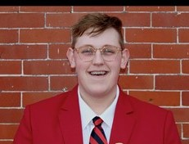

Kaci Mashino District 9 / Region C  My name is Kaci Mashino and I am from the Boyd County FCCLA Chapter. My passion for the red polo and blazer has ran deep for years. I find myself shining most in high energy social environments and STAR competitions. I've served as the Treasurer and President for my chapter, as well as District 9's Vice President of Community Service. I've had the privilege of traveling to National Leadership Conference the last two years and competing in National STAR Events, which were truly two trips of a lifetime. In my free time I enjoy listening to music and running. | 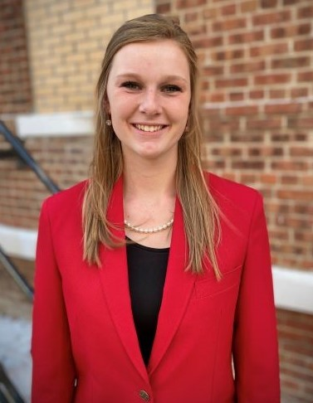

Alexis Richmond District 11 / Region D  My name is Alexis Richmond, and I am a junior at Chase County Schools. I have been an active member of my local FCCLA chapter  since 7th grade. I have had the opportunity to compete at National Leadership Conference each year through STAR events. I have also held many different leadership roles in my local chapter including treasurer and public relations officer. I have been a District 11 Officer for two terms. Currently, I am the Chairperson for the Community Leader SPOT team and the Vice-Coordinator on the Overall SPOT Council. | 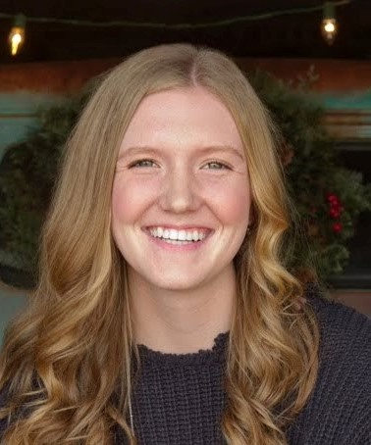

Sadie Heckert District 8 / Region C  Hi Nebraska FCCLA! My name is Sadie Heckert and I’m a sophomore at Neligh-Oakdale Public Schools and have served as a chapter officer for two years. Along with FCCLA, I’m involved in One-Act, Band, School Musical, All-School Play, and Choir. I love to babysit and enjoy umpiring USA Girl’s Softball. I have attended several district and state conferences, also including two national conferences. From these experiences, I have learned many organizational, communication, and time-management skills, all of which are beneficial for a State Officer to have. I look forward to serving on the 2020-2021 State Officer Team. | 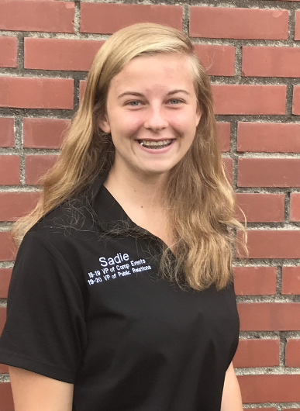
Emma Cline District 9 / Region C  Hey Nebraska FCCLA! I am so excited to be turning the next page in my story by running for the Nebraska State Officer Team this year! I am in 11th grade at Ord High School and am very active in my FCCLA Chapter! I currently serve as my Chapter's President along with serving as the District 9 Secretary. Along with FCCLA, I am also involved in many other school activities including Student Council, Speech, and Cheerleading! I am so excited to take this next step in leadership and am so eager to see what the future holds for Nebraska FCCLA! | 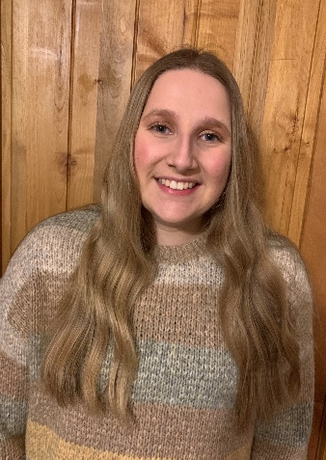

Emily Pedersen District 6 / Region C  Family has always been important to me. As a child, I remember laughing and playing with my older sister and parents during game night. These memories fill me with joy. While in FCCLA, I have experienced this same joy through my expanding FCCLA family. By serving as my local chapter events co-chair and as a member of the State Peer Education Officer Team, I have seen how FCCLA provides many opportunities for members to grow as leaders and individuals while maintaining strong moral principles, which is why I want to become a State Officer and continue to promote family values. | 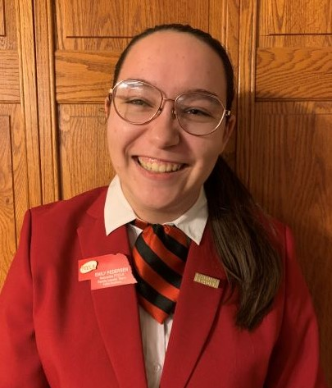

Alexis Butterfield District 9 / Region C  I have been a member of FCCLA since I was in seventh grade, and I have loved every second of it. I have held three different offices in my own FCCLA chapter and have been an active member. I am a three-time national STAR qualifier and Knowledge Bowl finalist. I attended the 2019 National Fall Conference this past year and was a national volunteer. FCCLA has taught me so much throughout the years, and I am honored to be a part of such a great organization that provides amazing opportunities for students like me. | 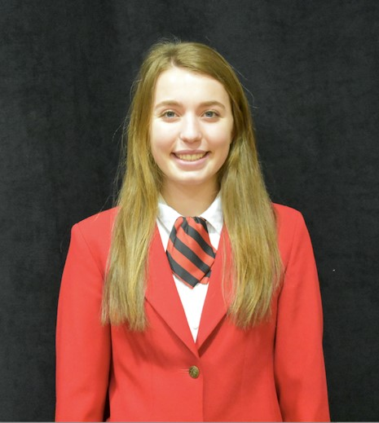

Cheyenne Ruhnke District 5 / Region B  Many of my FCCLA Experiences have been very memorable. Making everlasting friendships with the girls in my chapter is so amazing and I so lucky to be a part of an organization like this. Ever since being at my first SLC I knew I wanted to run for State Officer the next year. I hope to make my FCCLA chapter at my school more popular, and make my former adviser Mrs. Groth Proud of The Boone Central FCCLA Chapter. | 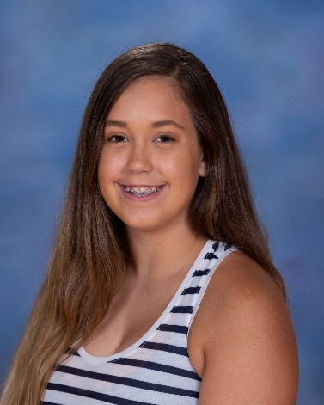

Alec Janousek District 1 / Region A  I traveled over 1,330 miles for great experiences learning about how to be a great leader, to compete, and to further my successes in FCCLA has bettered me in Family and Consumer Sciences, courses, career pathways, how to express my ideas more, be more confident in talking to other people I don’t know, and compromising with others when not seeing eye to eye. FCCLA has been an amazing experience and if I get on the State Officer team I hope to impact other peoples experience immensely. | 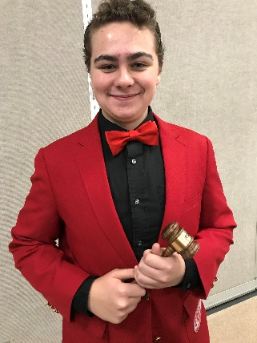

Conner Oberhauser District 5 / Region B  Hey Nebraska FCCLA! My name is Conner Oberhauser. I am a junior at Twin River Public Schools. I am involved in almost every activity offered at our school, but FCCLA is my true passion. I would like to become a state officer so that I can give back to this amazing organization that has given me so much over my years of involvement. I am currently the Overall Council Coordinator and the Family Leader Team Chairperson for the Sate Peer Officer Team. I would love the opportunity to lead this organization as a passionate and reliable state officer. | 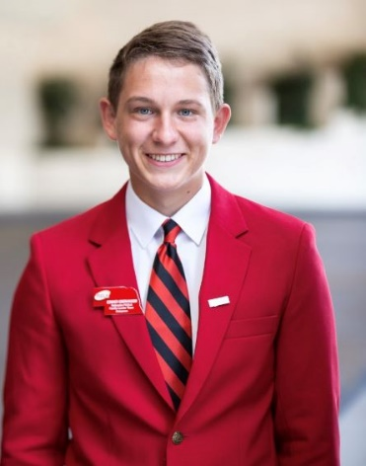

Sophia Birch District 2 / Region A  If I’m being completely honest, my involvement with FCCLA wasn’t because of an inherent drive to change the world. No, seventh grade Sophia Birch was concerned with getting her hands on one of those cool red blazers. Now I’m tenth grade Sophia Birch, and three years have taught me that FCCLA is about so much more than sharp-looking dress coats. STAR projects, chapter meetings, bake sales, and State and National Conferences have charged me with a desire to lead and make inspiring opportunities available to everyone through FCCLA. The red blazer is, of course, a nice bonus. | 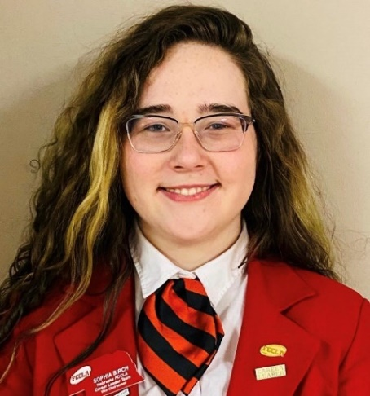

Ashlyn Schildt District 2 / Region A  “Don’t you know there’s a part of me that wants to go into the unknown.” – Elsa (Frozen 2)  I live my life like Elsa, always wanted to go into the unknown. The moment I started FCCLA I knew I wanted to break through my comfort zones. Through my many STAR projects I had no idea what I was going into, but those projects taught me so much. I learned to be persistent in times of weakness, and to always break through my limits. FCCLA has taken me into the unknown and I don’t regret a second of it. | 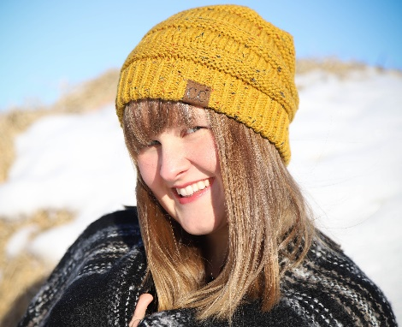

Cassidy June District 2 / Region A  Home is not a place, it is a feeling. Throughout my high school career I have been involved in many activities, but the only place I’ve always felt at home is FCCLA. I fell in love with FCCLA’s efforts to ecourage individuals to better their families and communities. Through a supportive environment I have already had four years in FCCLA. I have completed in STAR, became an officer, and presented sessions. FCCLA for me is about knowing where you belong, and being able to guide members in a direction that is positive and best fits who they are. | 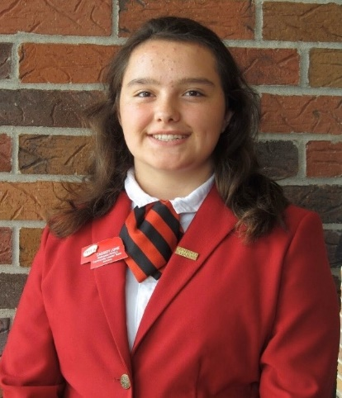

Rebekka Jay District 7 / Region B  My name is Rebekka Jay and I am a sophomore at Logan View Public Schools. I have been a member of FCCLA for 4 years and have filled many leadership offices including the State Peer Officer Team. I have a good work ethic, a strong passion for FCCLA and other extracurricular activities in my school and community, and I value time with friends and family. FCCLA has exposed me to many different people through state and national conferences and has shown me what a difference people can make when working together. | 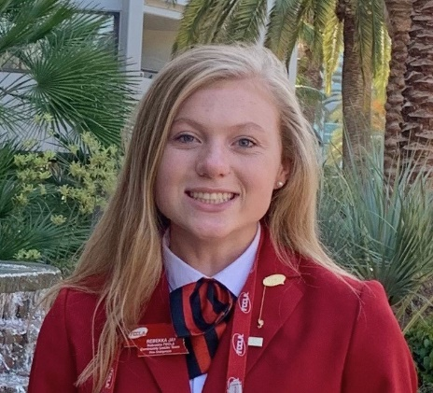

Taylor Svoboda District 10 / Region D  As a sophomore at Mullen High School, I love participating in extracurriculars and athletics, as well as volunteer coaching youth basketball. FCCLA has been a passion of mine since joining as a wide-eyed seventh grader. This passion is what lead me to become a part of the 2019-2020 Nebraska State Peer Officer Team. In addition to being on SPOT, I have attended multiple District, State, and National Leadership Conferences. Hard work, dedication, and focus have helped me to achieve many things, including placing both 11th and 2nd nationally in different STAR Events. | 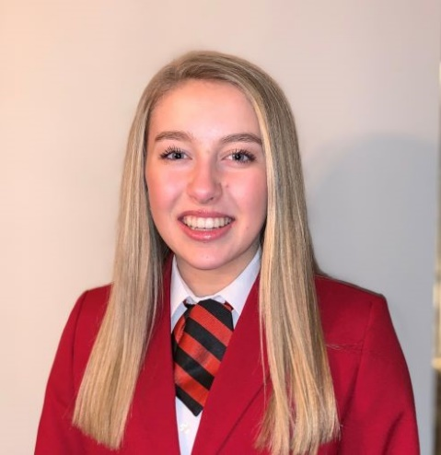

Samuel Coble District 10 / Region D  I’m a small town, country kid, and if I could tell the world anything it would be; have a positive attitude, it will change everything. When I realized I have the opportunity to become a Nebraska State FCCLA Officer I instantly wanted to apply because if there is one thing I couldn’t make it through high school without, it would be FCCLA. Since becoming an FCCLA member I have developed leadership traits, public speaking skills, and time management skills, all valuable traits at any age! That’s my story, and I’m proud to know it’s a part of our FCCLA Story! | 