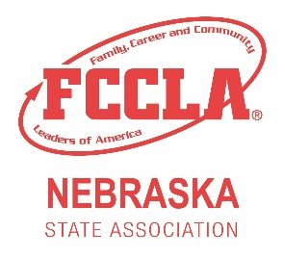
Fuel YOUR Passion Award:

This award was created to showcase the development of Nebraska FCCLA chapters. Chapters are asked to reflect on their involvement in Membership, Community Service, Involvement on a State Level, Involvement on a National Level, and National Program Efforts.
Directions:
Please fill out the application below comparing what you chapter has done this school year compared to the prior one. Fill out each section with a brief description of what your chapter did that given year. Once you have wrote a brief description please also be sure to attach pictures that correlate with your chapter's activity in the space given below. Submit this application by March 1st.
The chapter with the most improvement overall in all categories will be awarded the Fuel YOUR Passion Award.

Submit by March 1st to:
Kristin Vest, Nebraska FCCLA State Adviser
301 Centennial Mall S
PO Box 94987
Lincoln, NE 68509
Or email to: kristin.vest@nebraska.gov

Fuel YOUR Passion Award

Chapter Name: _________________________ Adviser: ___________________

Type of Chapter: ____ Middle/Jr. ____ Sr. High ____ Combined

To the best of our knowledge, this application is filled out accurately and completely.

Chapter Advisor Signature: ______________________________________

Chapter President Signature: _____________________________________

Membership:
2018-2019 Efforts
2019-2020 Efforts
Evidence: (Picture or flyer)

Community Service:
2018-2019 Efforts
2019-2020 Efforts
Evidence: (Picture or flyer)

Involvement on a State Level:
2018-2019 Efforts
2019-2020 Efforts
Evidence: (Picture or flyer)

Involvement on a National Level:
2018-2019 Efforts
2019-2020 Efforts
Evidence: (Picture or flyer)

National Program Efforts:
2018-2019 Efforts
2019-2020 Efforts
Evidence: (Picture or flyer)

