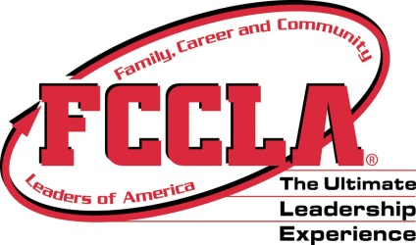
Feed Nebraska Project Ideas

Need help coming up with an idea for Feed Nebraska? Check out some of the ideas below!

Promote No Kid Hungry by having people sign the pledge to commit to helping to end childhood hunger at http://www.nokidhungry.org/pledge/action.

Collect food items at school, the grocery store, or around the neighborhood to donate to a local food pantry.

Wear orange on a special day to raise awareness of No Kid Hungry.

Educate others about the merits of making your own food both in terms of price and nutrition. Spend time making simple snacks or sharing recipes.

Collect loose change from friends, family, students, teachers, etc. and donate it to a local organization dedicated to ending hunger.

Host an event such as a bake sale, carwash, carnival, fun run, or silent auction and donate proceeds to local backpack food program, food bank or Share our Strength.

Have a canned food drive with a ball game or other community event to raise awareness of food needs and hunger.

Volunteer at a local food pantry to stock shelves, clean, or fulfill other personnel needs.

Trick-or-Treat for canned goods around your community. Dress up in costume for even more fun!

Share healthy snacks with elementary students for their holiday parties and events.

Challenge classes at the school to beat each other in pounds of food raised for a local food pantry.

Pledge to improve personal eating habits to make for a healthier individual.

Develop a menu and then go shopping to purchase items for a holiday meal. Donate the items to a local organization who services families in need for the holiday.

Host a Turkey Bowling contest and donate the frozen turkeys used.

Challenge members to cook a meal for their family and share the results.

Sell snacks at school and contribute funds to a local backpack food program that provides food to students during the weekends when school lunches aren’t available.

Teach peers and younger students about MyPlate.

Give prizes at a local basketball game for individuals who bring a canned food item to the game.

During the Super Bowl have your own competition between the two teams with the winner determined by the amount of donations given in each team’s honor.

Have an idea to share? Email it to nebraskafccla@gmail.com to help another chapter reach out!

